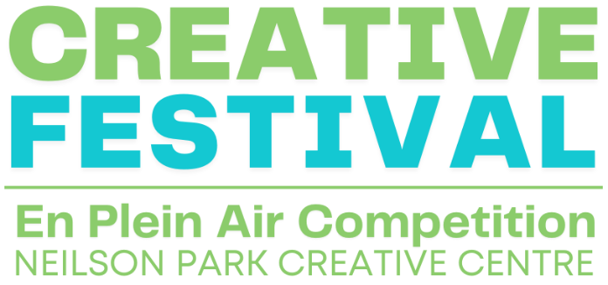

**Call for Entry – 2024 En Plein Air Competition**

**What is En Plein Air?**

En plein air, a French phrase meaning "in the open air," describes the process of painting a landscape outdoors.

**Project Description**Neilson Park Creative Centre is excited to announce its En Plein Air Competition on Saturday, July 13 at 10:00 a.m. to 3:00 p.m. Artists are invited to work en plein air in Neilson Park during the Neilson Park Creative Festival featuring art and fine craft vendors and live performances!

Artists may work in a location of their choice: in the woods, with the vendors or musicians – anywhere out-of-doors in Neilson Park or Markland Woods.

Artists must check-in, and may pick up their easels (if needed) inside the Neilson Park Creative Centre between 10:00 a.m. – 10:30 a.m. on July 13. Any time before 3:00 p.m. the artists may return the easels and drop off their completed paintings at the same location inside the Centre. The jurying will take place at 3:15 p.m. sharp with an artists’ reception and award ceremony at 3:30 p.m.

The artworks produced during the competition will belong to the artists. Neilson Park Creative Centre reserves the right to use images for promotional purposes.

**Competition Categories and Entry Fee**

There are two competition categories:

1. Youth, 13 – 18 years of age, free of charge to enter

2. Adults, 18+, $5.00 entry fee

**Awards**  
Youth category: First, $100; Second, $75; Third, $50   
Adult category: First, $200; Second, $100; Third, $75

**Registration**

Participants are required to register online, by phone or by visiting in person. Registration is complete once registrant information and payment have been received and processed.

* Online

To register on our website, click on the “Explore” tab and then the “Events” button at the top of our website. Click on the “Neilson Park Creative Festival” button to see the En Plein Air Competition. To purchase, click the course code to make your payment in the shopping cart. We accept payment by credit card in our shopping cart. Youth participants must register although there is no cost.

* By phone

To register by phone, call 416-622-5294 to speak with a customer service representative. Credit card payments are accepted over the phone.

* In person

Please visit us in person to register. We accept payment by credit card, debit, cheque or cash.

**Materials**

Artists are responsible for bringing their own art supplies, umbrellas and seating, etc. Neilson Park will provide a full-sized easel to each artist. Access to water and public washrooms are available inside Neilson Park Creative Centre.

**Size Restrictions**

There are no size restrictions and artists may paint with oils, acrylics or watercolours on the surface of their choice.

**Juror**

**Jenneen Beattie***Multidisciplinary Artist*

Jenneen Marie Beattie holds a Graduate Certificate in Arts Administration and Cultural Management from Humber College. She received her BFA from OCADU with a major in Criticism and Curatorial Practices. She participated in an independent studio placement at the Winchester School of Art, UK. She was an Artscape Daniels Launchpad fellowship participant from 2019-2022. Her work in textile-based media investigates the connections between memory and fabrics. The work attempts to capture and preserve memories, it addresses notions of souvenir-ship, conservation, and keepsakes. Additionally, the work contains an embedded message around repurposing materials, sustainability, and supporting local markets. She has managed public art projects for the City of Toronto, Cultural Hotspot, Doors Open, StreetARToronto, MOCA Toronto, Toronto Biennial, Toronto Zoo, Nuit Blanche, Cavalcade of Lights, Mural Routes, and Yonge-Dundas Square.

**Rules and Regulations**

* Artists must be registered for the event to participate in the show and awards ceremony.
* Artists may apply grounds to their support of choice prior to check-in.
* Each work of art must be started and completed en plein air (outside). In case of inclement weather, artists may move inside the Centre in a specially designated studio area.
* Artists must provide their own materials.
* Artists may paint any subject/scene outdoors throughout Neilson Park and Markland Woods.
* Artwork for the show must be submitted inside Neilson Park Creative Centre by 3:00 pm on Saturday, July 13.
* Artists may select up to 2 pieces of work they created en plein air during the festival for jurying.
* All artwork for the show must have an identifying label attached on the back. Labels can be found on this form and will also be available upon drop-off.
* NPCC staff will set up the artwork for the jurying process.
* Artists may take their work home after the awards ceremony beginning at 3:30 p.m.

**Social Media**

We encourage artists to share posts on their social media and websites and tag us @NPCCarts

Follow us @NPCCarts on Facebook, Instagram and Twitter.

Visit us at www.neilsonparkcreativecentre.com

**For questions or info email Cory: gallery@neilsonparkcreativecentre.com**

**PLEIN AIR ENTRY FORM**

Artist’s First and Last Name __________________________________________________________

Email _______________________________________Phone________________________________

**Submission checklist**

**□** Complete and submit application form.  
**□** Pay entry fee. Entry fees are non-refundable. Note: youth 13-17 years of age may participate free of charge but must register.

**NPCC 2024 Plein Air Label**

Please affix labels temporarily onto the back of the artwork when completed.

Artist Name:_________________________________________________________________________

Artist Phone:_________________________________________________________________________

Artwork Title:_________________________________________________________________________

Artwork Medium:______________________________________________________________________

Price:______________________________ For Sale □ Not For Sale □

**NPCC 2024 Plein Air Label**

Please affix labels temporarily onto the back of the artwork when completed.

Artist Name:_________________________________________________________________________

Artist Phone:_________________________________________________________________________

Artwork Title:_________________________________________________________________________

Artwork Medium:______________________________________________________________________

Price:______________________________ For Sale □ Not For Sale □